**R code chunks and their outputs**

1. **Installing and importing necessary libraries**

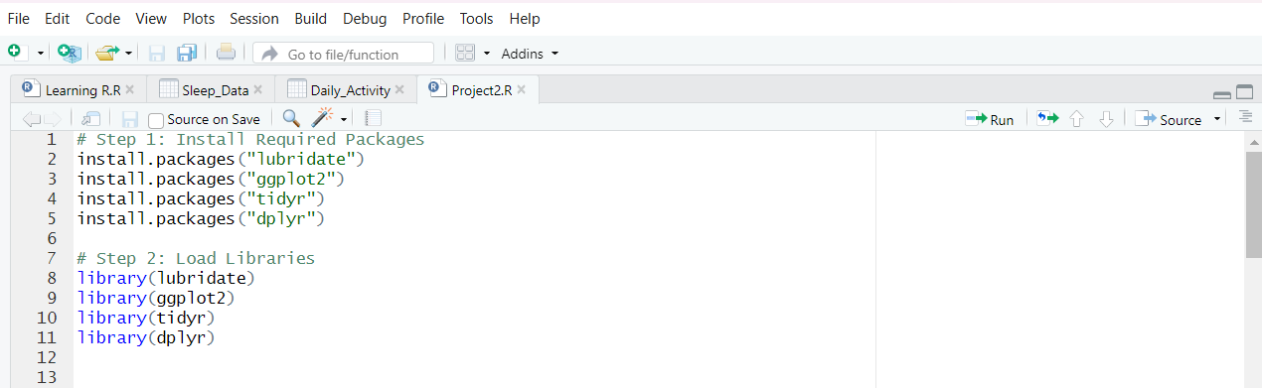

**Output:**

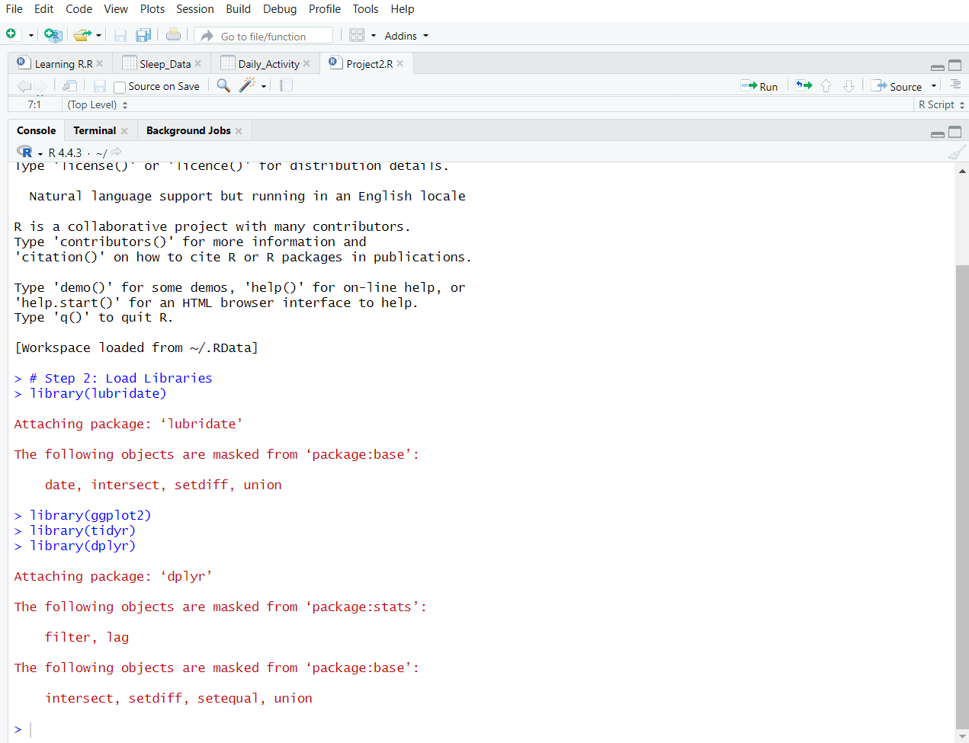

1. **Checking if data exists then importing**

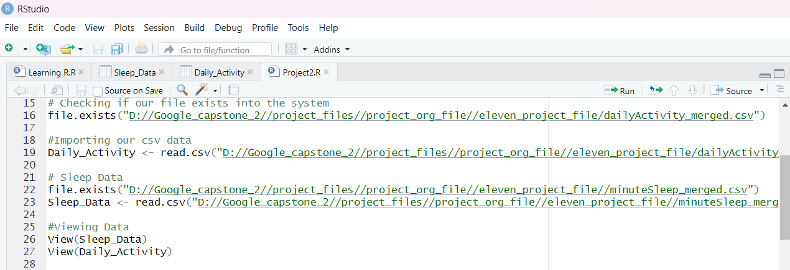

**Output:**

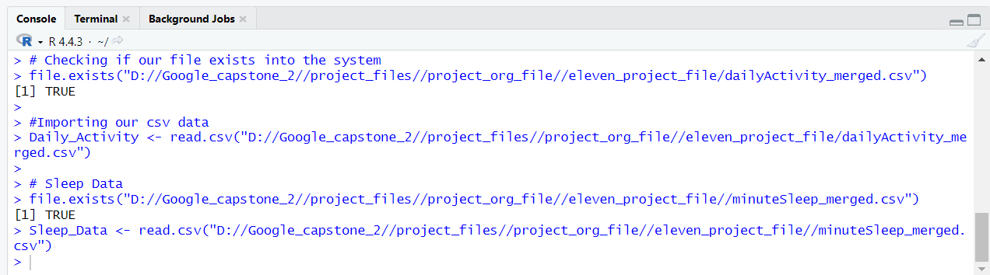

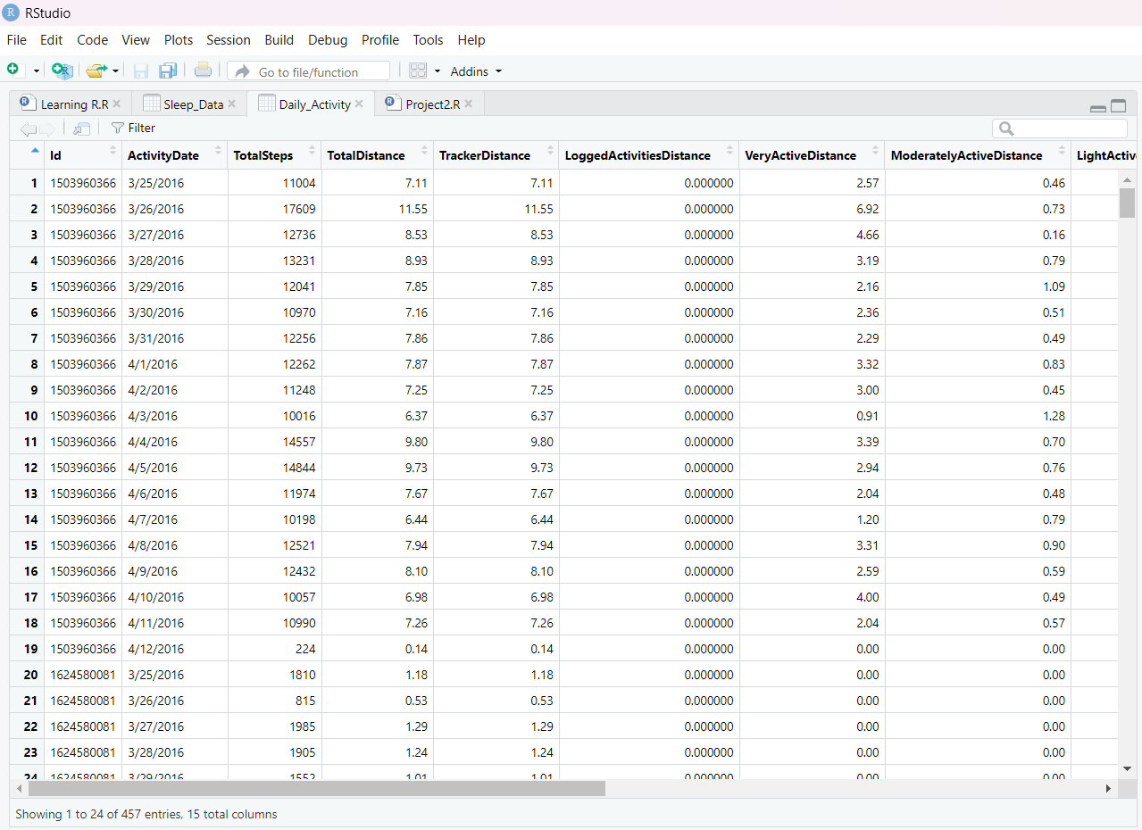

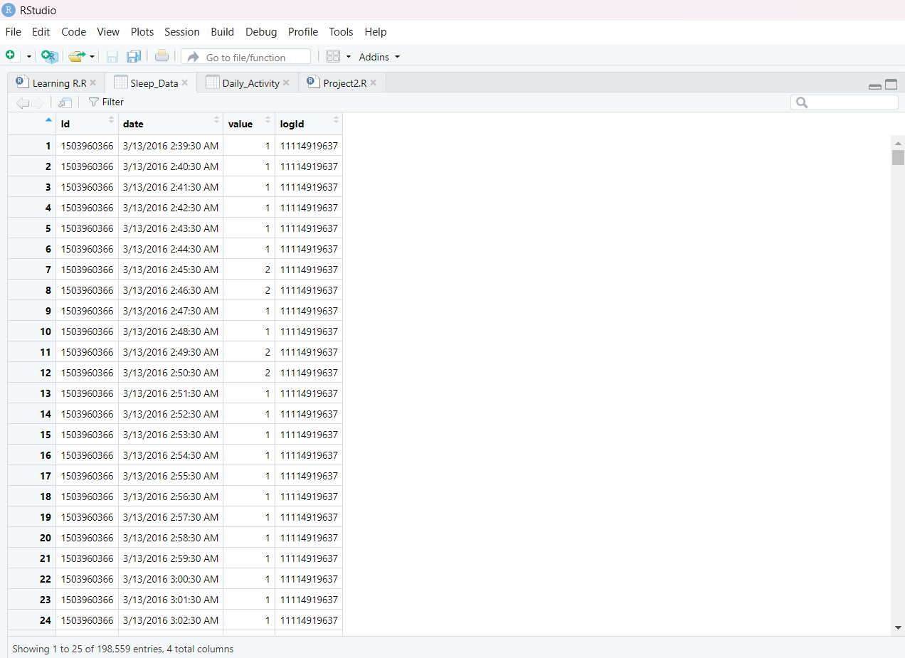

1. **Creating DataFrame and Standardising data**

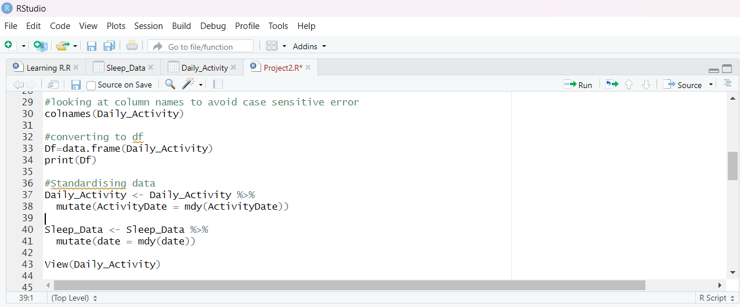

**Output:**

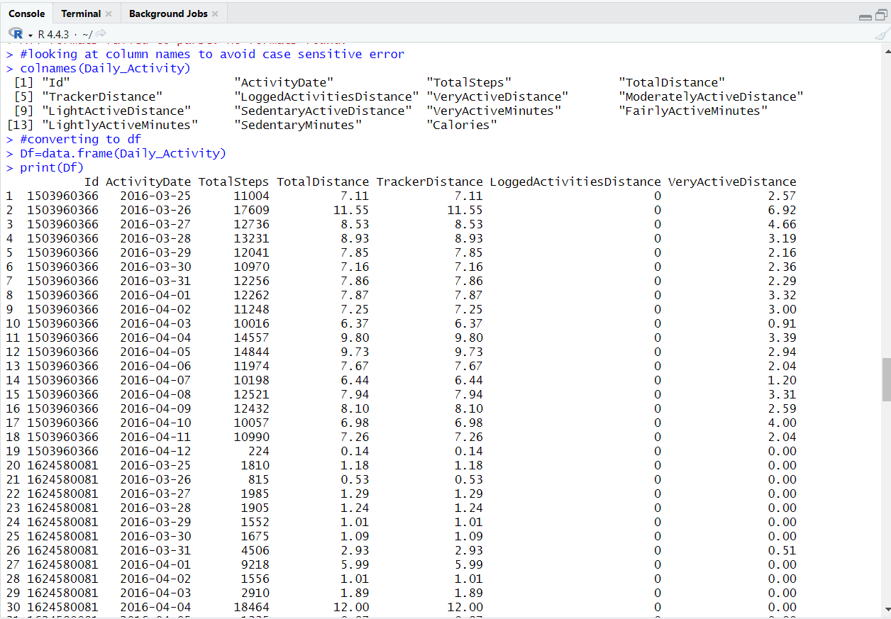

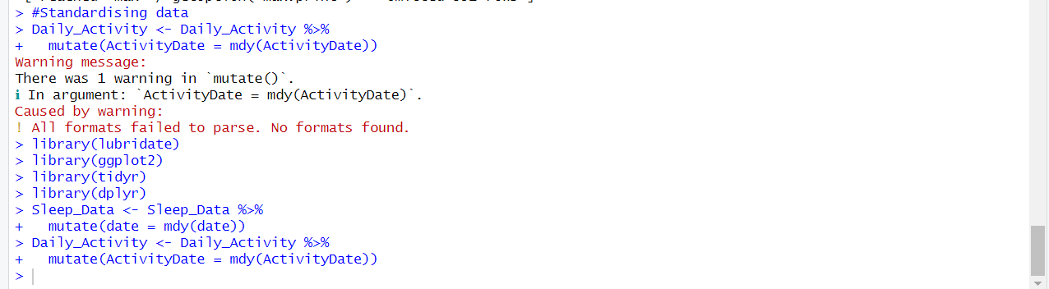

1. **Adding weekday column & finding mean of steps by weekday**

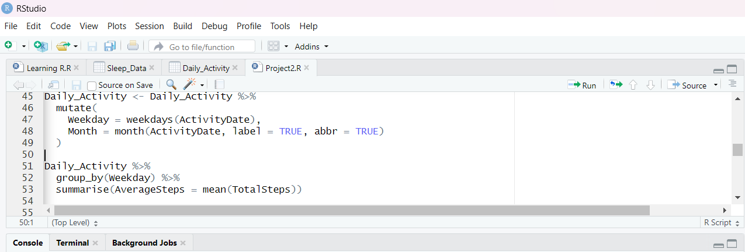

**Output:**

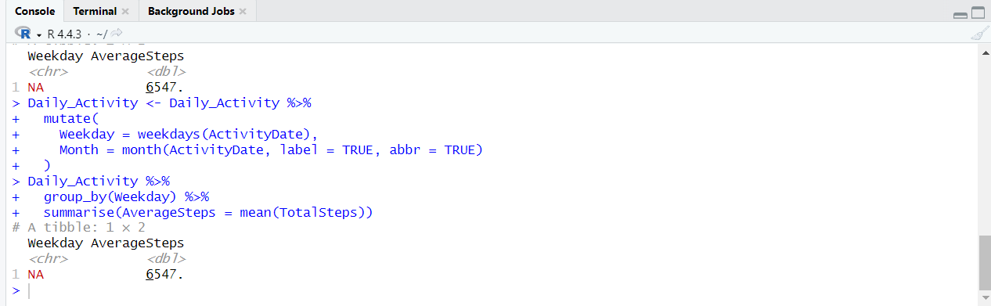

**Analysing Data**

1. **Average steps by weekday & Establishing joins**

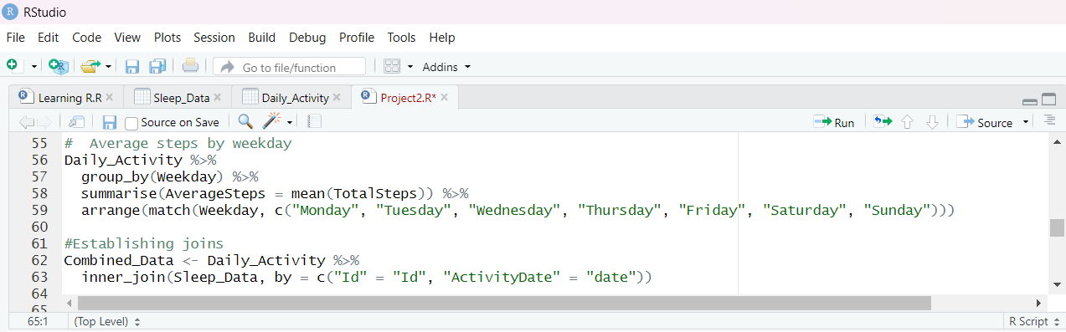

**Output:**

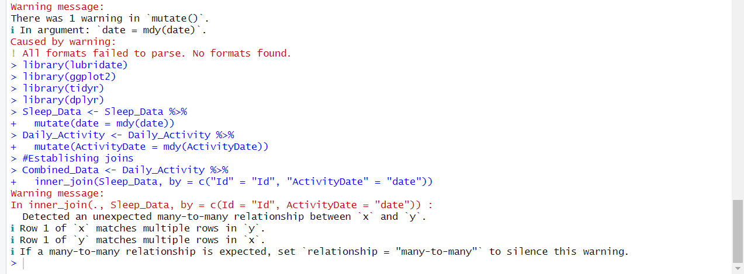

1. **Average sleep on weekends vs weekdays & Correlation between steps and calories**

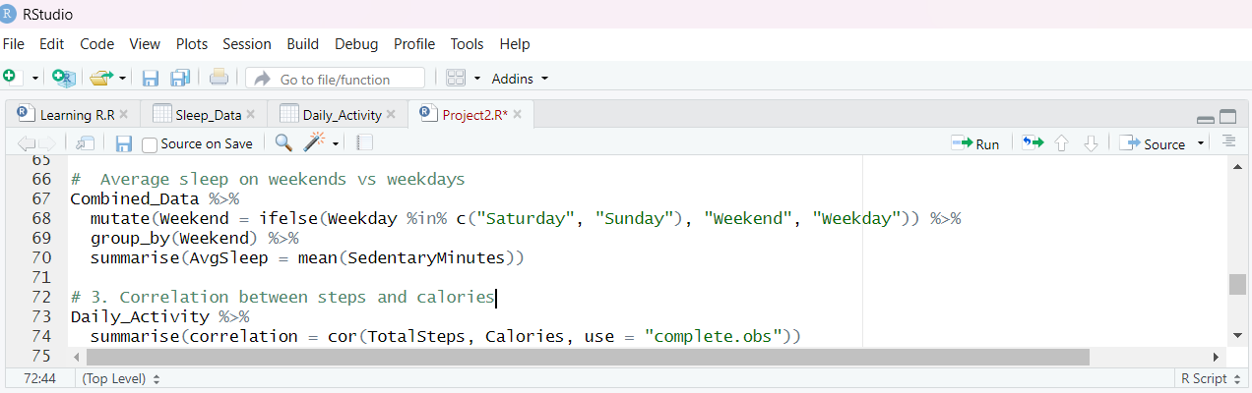

**Output:**

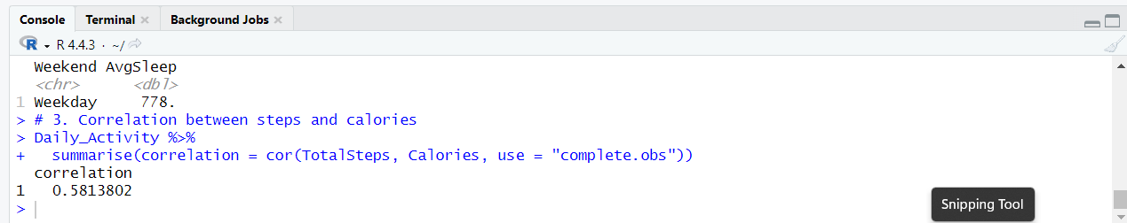

1. **Creating Visualization**

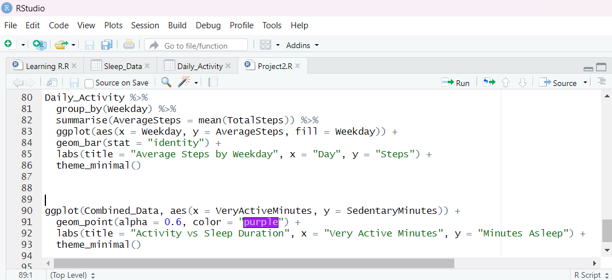

**Output:**

